Hoisting the Mainsail
Hoisting and lowering the mainsail requires two crew members in addition to the helmsman, one at the mast and another in the cockpit on the halyard winch.

- If fitted, remove the mast sail cover and stow it in a cockpit locker.
- Unzip the sail boom bag.
- Disconnect the mainsail halyard from the end of the boom and attach it to the headboard of the mainsail.
- Ensure there is no slack in the halyard and the halyard is not fouled in the lazy jacks.
- Ensure all reefing lines and their jammers are completely loose and the mainsheet and boom vang are eased.
- Take the lazy jacks forward to the mast.
- Before hoisting, bring the yacht head to wind under power at slow speed.
- Hoist the mainsail initially by hand at the mast, then on the halyard winch, watching the sail to ensure it runs up freely.
- Maintain the yacht head to wind, monitor the sail until it is fully hoisted and tensioned.
- Jam the main halyard and release it from the winch.
- Tension the boom vang and adjust mainsail sheet as required.

Lowering the Mainsail
- Ensure the lazy jacks are properly set.
- Bring the yacht head to wind under power at slow speed and haul in the mainsheet and centre the traveller.
- Put the main halyard on the halyard winch, take up the strain and release the jammer.
- Lower the mainsail at an appropriate rate for the conditions and flake it on the boom.
- Zip up the boom bag and fit the mainsail cover to reduce UV damage to the sail.
- If necessary release the main halyard from the sail and attach to the end of the boom.

Reefing the mainsail
Ideally you need three people in the cockpit during reefing operations — one to steer, one to ease or hoist the main halyard, and one to winch in or release the reefing lines.
- Bring the yacht up to the wind when reefing or shaking out a reef.
- Ease the boom vang then the main sheet until the sail starts to flap. The boom must be free to ride up to the sail.
- Continue sailing on the genoa or use the diesel.
- Do not pull in loose reefing lines for the sake of tidiness, it makes re-hoisting the mainsail much harder.

1st, 2nd reefs

The 1st and 2nd reefs on Namadgi are ‘single line’ reefing systems in which the tension in the reefing line is converted to equal tension in both the luff line and the leech line. See the diagram below.

The procedure for reefing is simple. Ease the vang and then the mainsail sheet to de-power the sail, lower the main halyard and winch in the appropriate reefing line.

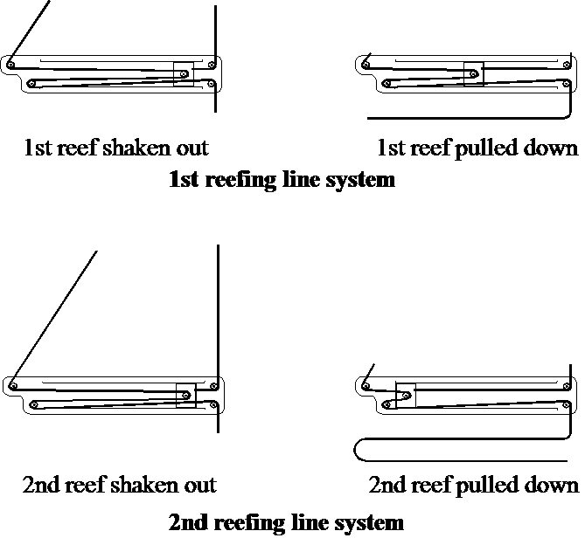

To shake out a reef, ease the boom vang and then the mainsail sheet, release the reefing line and winch in the mainsail halyard to the correct tension. Take in the mainsail sheet, then tension the vang.

3rd reef

The 3rd reef has one line that tensions only the leech line. The 3rd reef tack eye is lowered and secured on the reefing hook at the gooseneck of the boom and mast. Otherwise the same procedure applies for the 3rd reef as the 1st and 2nd reef.

